

Dr. Christina, Cook inc.
2024-06-22
Dr. Cook
020 Grant Rapid, West Angelaview, PA 70094
Phone: 7214332285
Fax: 4461954172

Re: Maria, Reed
PHN: 3537151518
Birthdate: 18-Apr-1973
Address: PSC 1908, Box 6892, APO AE 20908
Patient number: 7034786366

To Whom It May Concern:

This is a medical letter to state the above patient is pregnant with expected delivery date of 25-Apr-2025. Hoping this information is satisfactory for your requirements.

Thank you.

Sincerely,
Dr. Christina, Cook
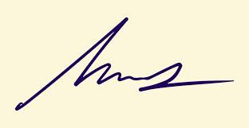
FRCS© NCMP
Clinical Assistant Professor, UBC
Department of Obstetrics and Gynecology SMH

